Python Programming Assignment Submission
1. Grade Checker
Objective
To take marks as input from the user and print the corresponding grade using conditional statements.
Code Used
score = int(input("Enter your score: "))
if score >= 90:
print("Grade: A")
elif score >= 80:
print("Grade: B")
elif score >= 70:
print("Grade: C")
elif score >= 60:
print("Grade: D")
else:
print("Grade: F")
Explanation
The program takes the student’s score as input.
Using if–elif–else conditions, the score is checked against predefined ranges and the appropriate grade is printed.
This demonstrates the use of decision-making statements in Python.

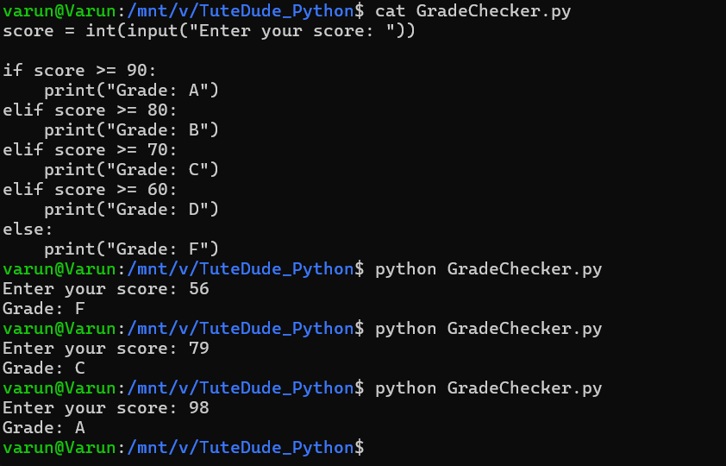

2. Student Grades Using Dictionary
Objective
To manage student names and grades using a dictionary.
Code Used
students = {}

while True:
print("\n1. Add Student")
print("2. Update Student Grade")
print("3. Display All Students")
print("4. Exit")

choice = input("Enter your choice: ")

if choice == "1":
name = input("Enter student name: ")
grade = input("Enter grade: ")
students[name] = grade
print("Student added successfully.")

elif choice == "2":
name = input("Enter student name to update: ")
if name in students:
grade = input("Enter new grade: ")
students[name] = grade
print("Grade updated successfully.")
else:
print("Student not found.")

elif choice == "3":
print("\nStudent Grades:")
for name, grade in students.items():
print(name, ":", grade)

elif choice == "4":
break
Explanation
A dictionary is used where:
- Keys represent student names
- Values represent grades
The program allows:
- Adding a new student
- Updating an existing student’s grade
- Displaying all stored student records

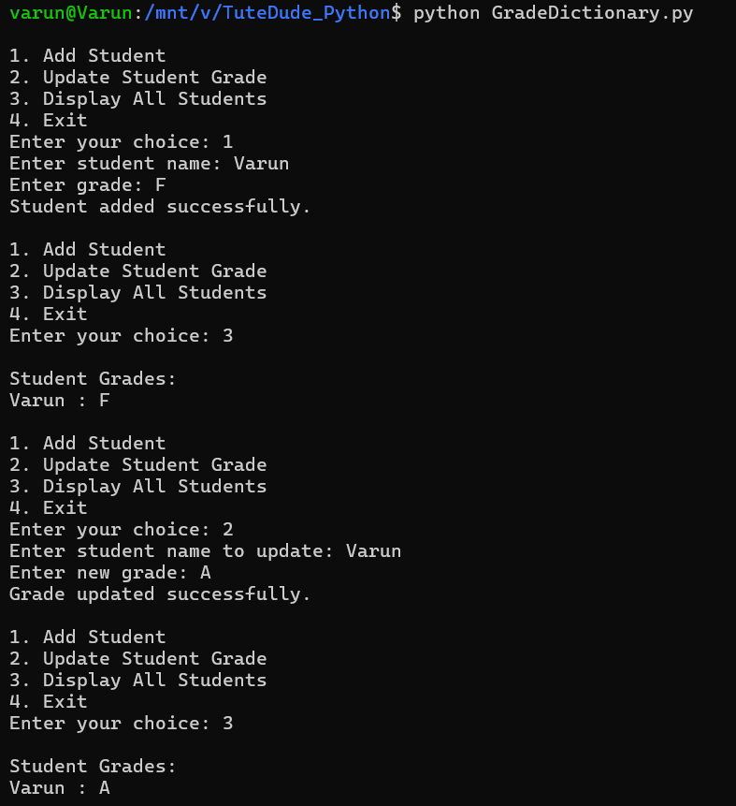

3. Writing to a File
Objective
To create a text file and write content into it.
Code Used
file = open("sample.txt", "w")
file.write("Hello, this is a sample file.\n")
file.write("This content is written using Python.")
file.close()
Explanation
The file is opened in write (w) mode.
The write() function is used to add content to the file.
The file is then closed to save the data properly.

4. Reading from a File
Objective
To read and display the contents of a text file.
Code Used
file = open("sample.txt", "r")
content = file.read()
print(content)
file.close()
Explanation
The file is opened in read (r) mode.
The read() function reads the entire file content and prints it on the screen.

